# 

Guideline for the ONLINE S3 toolbox

tool/application

RIS3 Open Data Tool

ONLINE S3 – 710659 – Guidelines for the pilot experimentation phase



Content

Background and rational 3

Description of the application 4

Benefits to key actors and stakeholders 5

Key issues and requirements 6

A STEP-BY-STEP GUIDE 7

Further information 8

References 9

**Figures**

Figure 1 Rational behind this ONLINE S3 application 3

Figure 2 Overview of this ONLINE S3 application 4

Figure 3 Benefits to stakeholders when using this ONLINE S3 application 5

Figure 4 Key issues when using this ONLINE S3 application 6

Figure 5 Step 1 for using this ONLINE S3 application 7

Figure 6 Step 2 for using this ONLINE S3 application 7

Figure 7 Step 3 for using this ONLINE S3 application 7

**HISTORY OF CHANGES**

|  |  |  |  |
| --- | --- | --- | --- |
| **Version** | **Date** | **Contributing partner** | **Summary of changes** |
| Version 0.1 | 2016-10-07 | RIM | Structure of the document, elaboration of required information as a template for all tools |
| Version 1.0 | 2017-04-25 | IIL | Initial Draft |
|  |  |  |  |
|  |  |  |  |

**DISCLAIMER**

The opinion stated in this report reflects the opinion of the ONLINE S3 consortium and not the opinion of the European Commission.

**ACKNOWLEDGEMENT**

This document has been elaborated within the framework of the ONLINE S3 project, which has received funding from the European Union’s Horizon 2020 research and innovation programme under grant agreement No. 710659.

## Background and rational

Ongoing studies concerning the use of open data on EU Structural Funds have shown that most data currently published by EU national and regional authorities are not yet compatible with the fundamental requirements of the open data paradigm (Reggi, 2016). Data is rarely complete, accessible, timely, machine process-able and non-proprietary. Open Data Tools operate on such data overcoming the issues previously highlighted, making such data compatible and easily accessible.

An RIS3 Open Data Tool has been developed to facilitate the use of published open data concerning EU projects when tracking specialisations. The tool works as a form of data repository that enables the tracking of projects and initiatives implemented in each region.

Currently, open data tools are not widely used in non-publicly funded projects. However, the effective use of this tool, facilitates the tracking of project themes and topics in each region which maybe cross-referenced with S3 priorities. The data made available by the tool can be highly valuable in tracking progress towards defined objectives and vision, and to inform the RIS3 update process.

Figure 1 provides the rationale behind this ONLINE S3’s application.

Figure 1 Rational behind this ONLINE S3 application

## Description of the application

The RIS3 Open Data Tool is a form of data repository that allows for a **finely grained tracking of projects and initiatives** implemented in each region with **links to respective S3 priorities**. Data is mined using an automated collection system which mirrors the CORDIS (Community Research and Development Information Service) database (EU Publications Office, 2017) along with additional information extracted from project and coordinator websites.

An Open Data Platform (ODP) backend, based on CKAN, supports the tool. Together the ODP and Tool operate as a web directory of projects and organisation such that it enables users to **search for up-to-date information concerning regional projects** including project outcomes.

The ODP has full access to publicly available data through the ODP API (Application Programming Interface), which provides functions to access relevant data stored by the platform, and allows the inclusion of both structured and unstructured content such as data that may be available through individual project websites and progress reports as well as results through RIS3 innovation maps (see the description of method 5.6).

Figure 2 Overview of this ONLINE S3 application

## Benefits to key actors and stakeholders

Ongoing studies have highlighted a clear gap regarding the use of RIS3 implementation methods. Tools for tracking data concerning publicly funded projects and initiatives are not widely used which makes this process difficult and time-consuming without such an aid.

Policy makers and other interested parties will be able to use this RIS3 Open Data Tool to track progress within regions towards their objectives and collective vision. The tool will provide data on the number of projects implemented and their linkage to corresponding S3 priorities in order to facilitate this.This will aid in measuring progress against the vision of the S3 in the region.

The tool may also be useful for those taking part in the project as a means of tracking how well they have progressed against the projects objectives and as a means of publicising projects and expertise among peers.

Subsequently, the tool also has an impact on the data analysis method 5.6: RIS3 Innovation Maps. The quality of the data that is processed and presented by this is influenced by the operation of the Open Data Tool, as it will act as one of its main data sources.

Figure 3 Benefits to stakeholders when using this ONLINE S3 application

*Case Studies:*

*Good practices in this regard include the open data storehouse of Tekes in Finland, which allows to search for projects and beneficiaries that have been funded through Tekes programmes [21]. The UK also has similar approaches to open data: the Gateway to Research database [22] includes data on all publicly funded projects by Innovate UK and the Research Councils.*

## Key issues and requirements

**Requirements**

Various types of data concerning RIS3 projects are sourced for compilation by the Open Data Tool Platform, each source is considered reliable and up-to-date. Data sources are synchronised to enable the effective tracking of changes in terms of user notifications. This is achieved using data archived by the CORDIS project where a generic, standardised model has been devised to represent projects and organisations. The Open Data Tool builds upon this offering further information extracted to create linkage between each project and the corresponding S3 priority to be supported by the objectives of the project.

Relevant Data sources include:

* CORDIS
  + Regional S3 Project Websites
  + Regional S3 Project Progress Review Reports
* Online S3 Platform
  + Regional Innovation Maps

|  |  |  |
| --- | --- | --- |
| Project |  | Organisation |
| Project ID, Acronym, Title, URL | Organisation ID, Short Name, Name, Address |
| Coordinator, Country, Consortium | Projects, Roles, State of Participation, Activity Type |
| Call, Programme, Funding Scheme |  |
| Objective, Topics, Subjects |

**Process**

Figure 4 Key issues when using this ONLINE S3 application

**Timeframe**

Data made available by the tool is to be fed into the Innovation Maps tool for further analysis.

## A STEP-BY-STEP GUIDE

1. Define a search term concerning one of the following properties of the projects in interest:

* Project- Title, Acronym, ID, Objective;
* Coordinator, Country of Origin;
* Call, Programme, Funding Scheme;

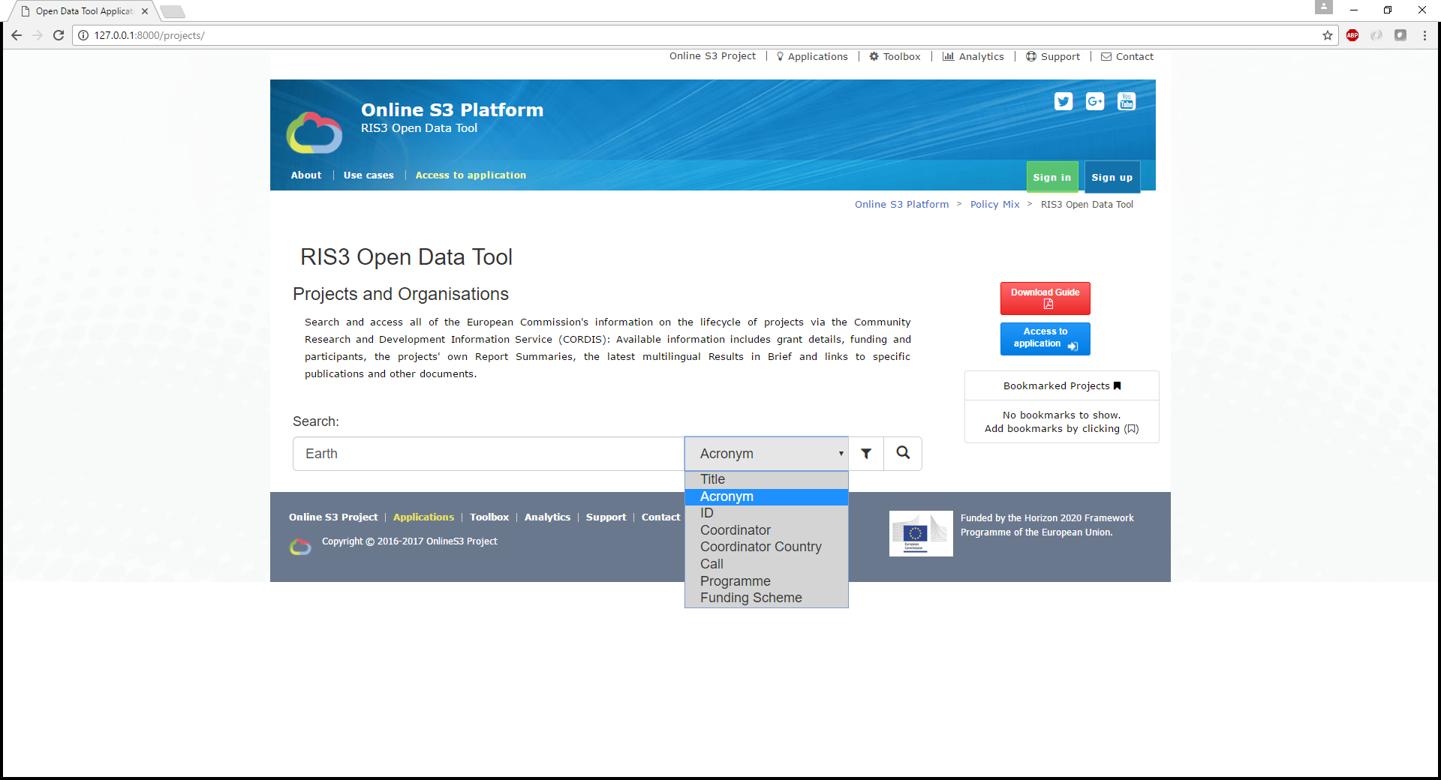

1. Select frameworks, filters and sorting parameters to refine the search further to narrow down on projects of interest.

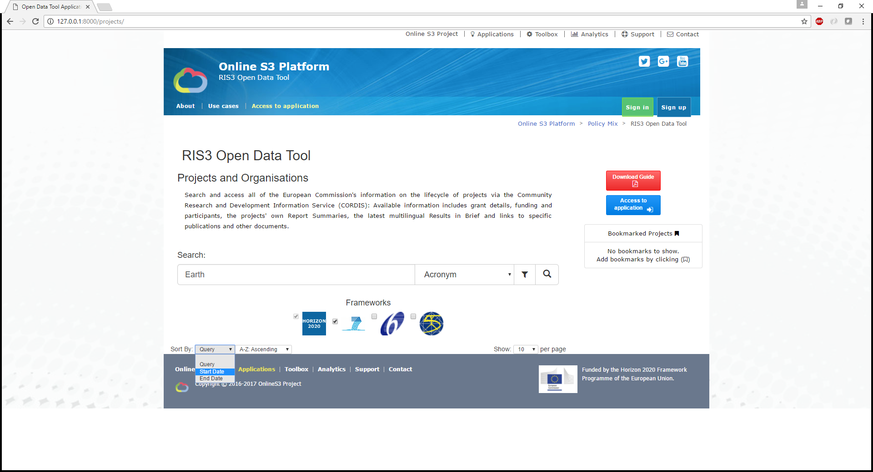

Figure 5 Step 1 for using this ONLINE S3 application

1. Explore the search results concerning projects and participating organisations.

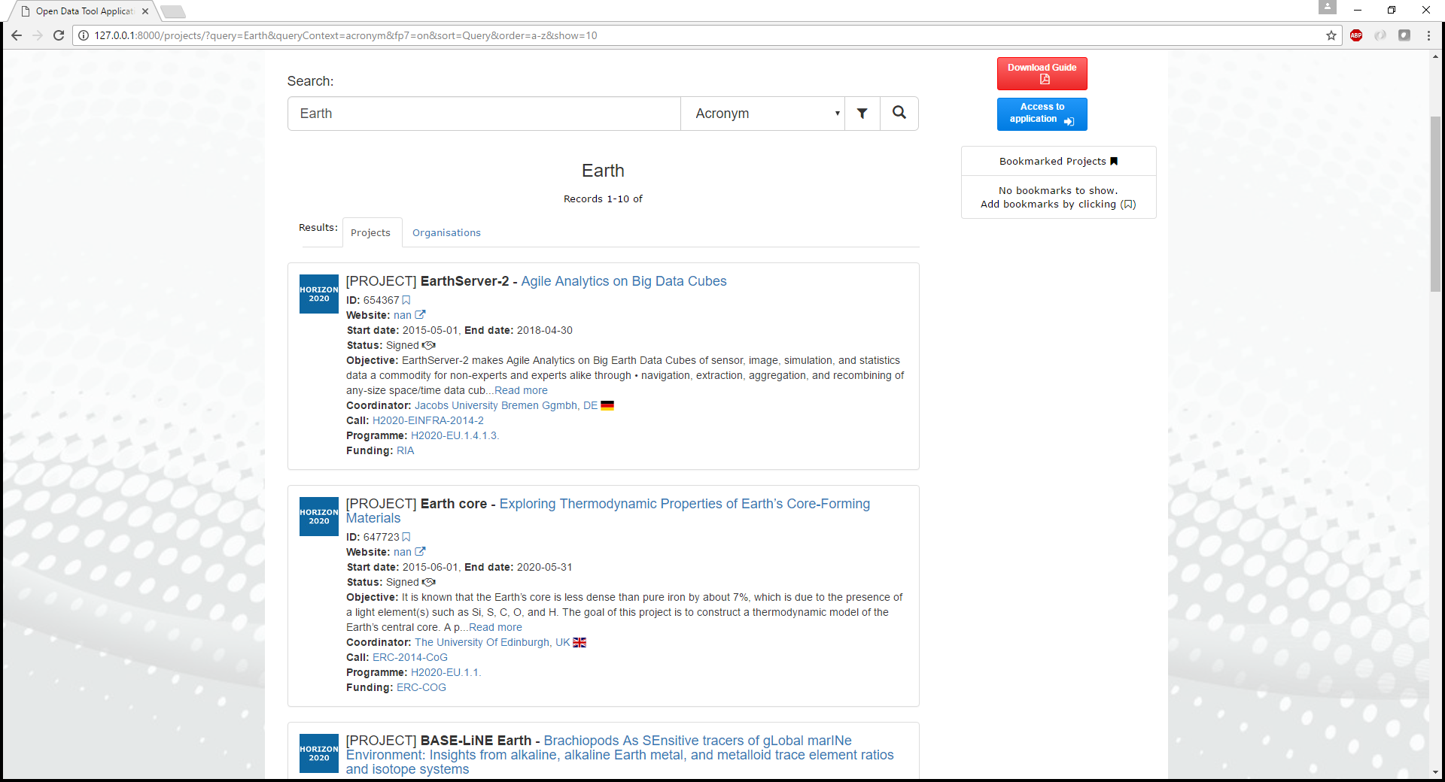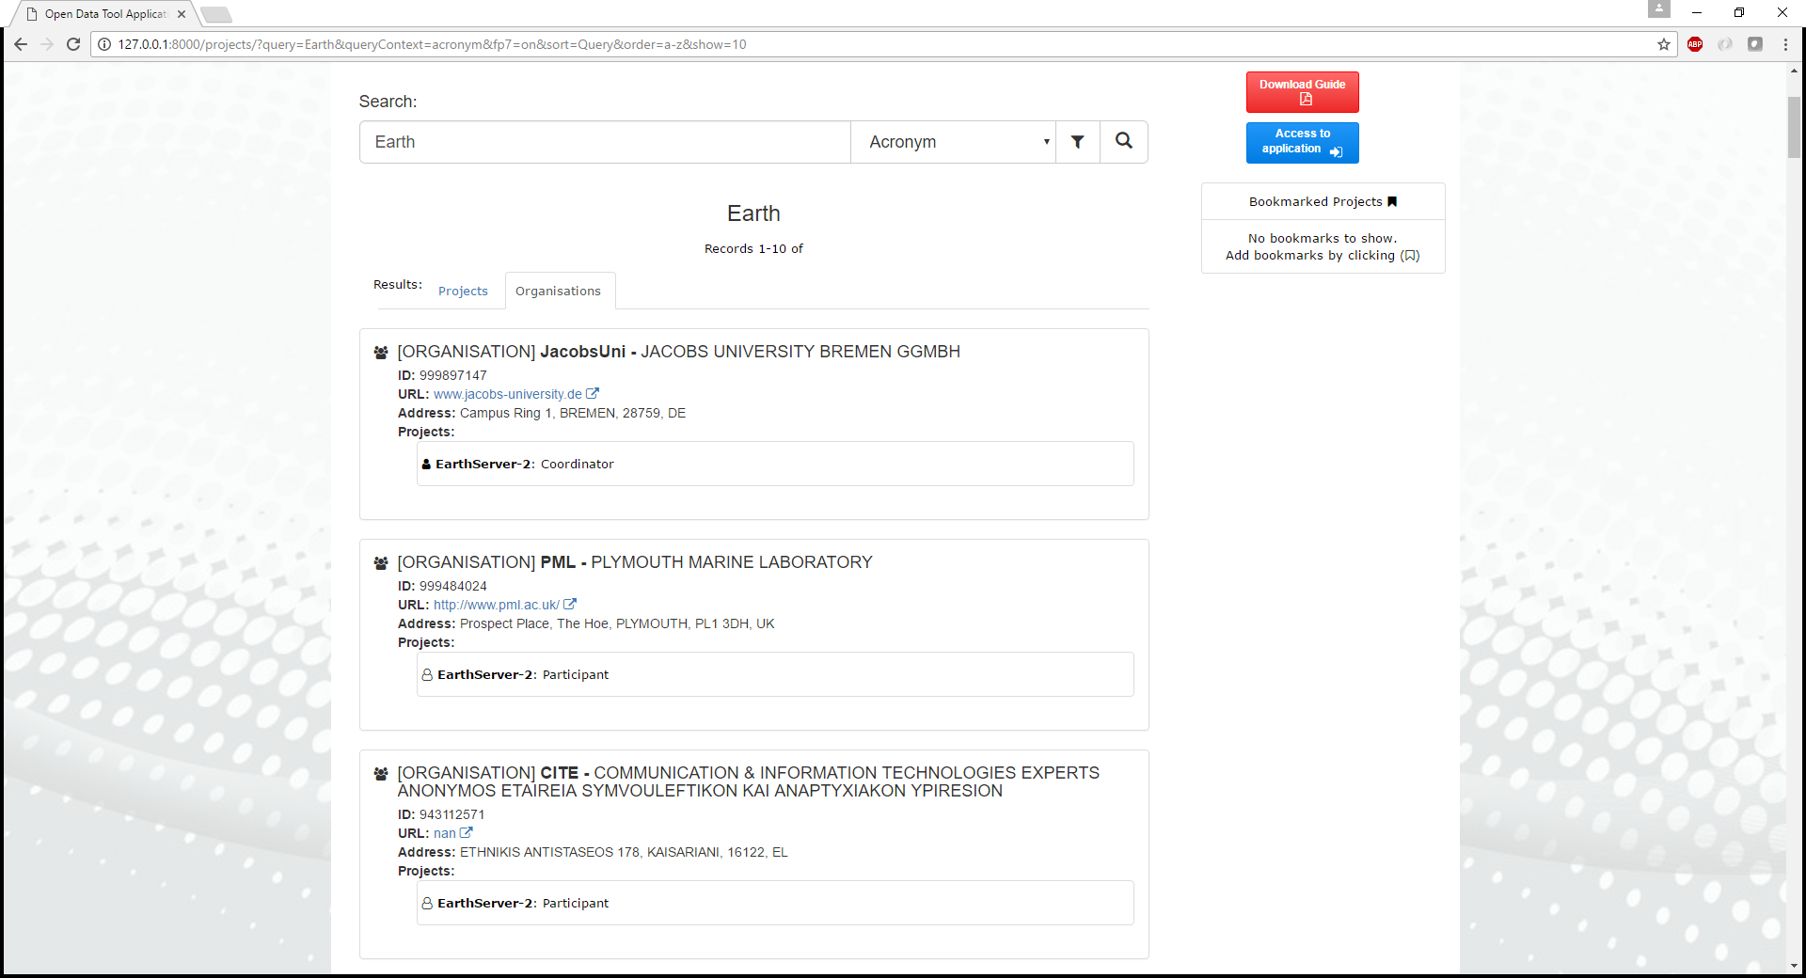

1. Select a project to get more information concerning the consortium and breakdown.

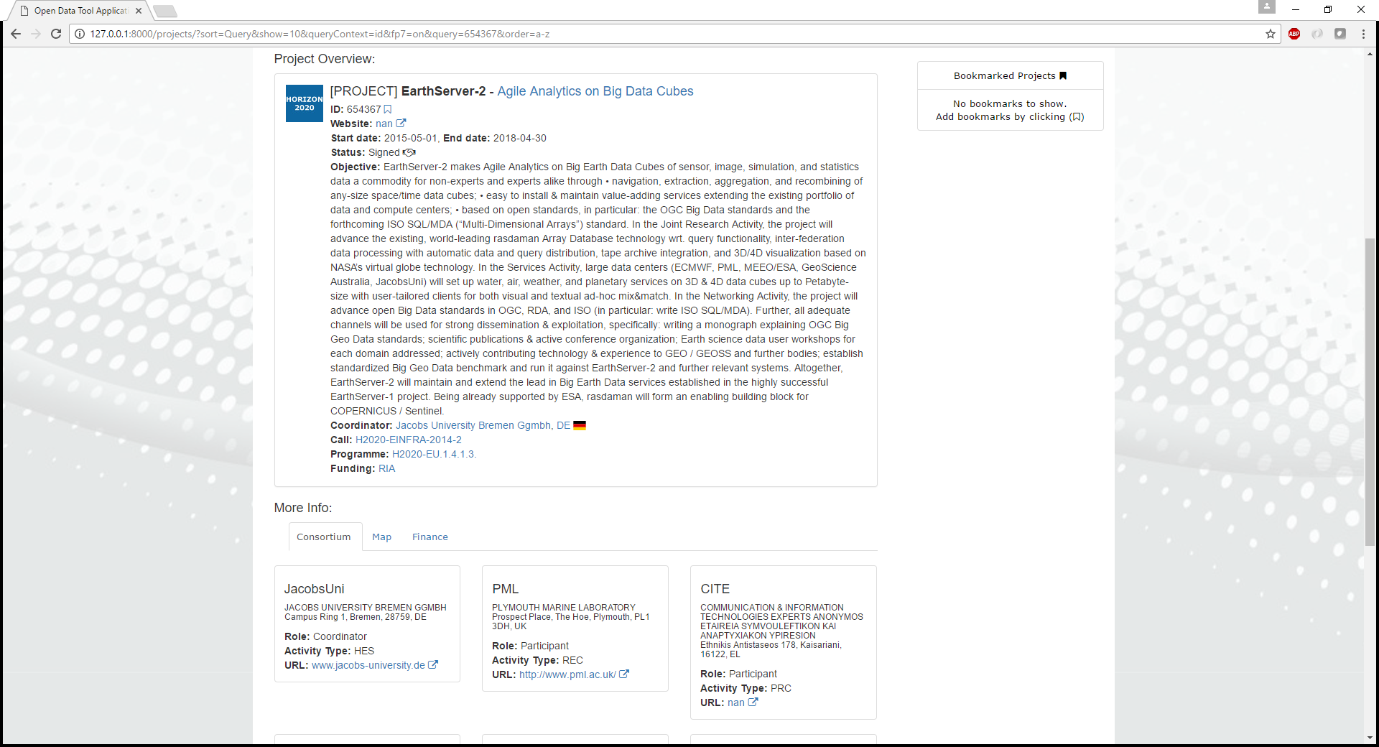

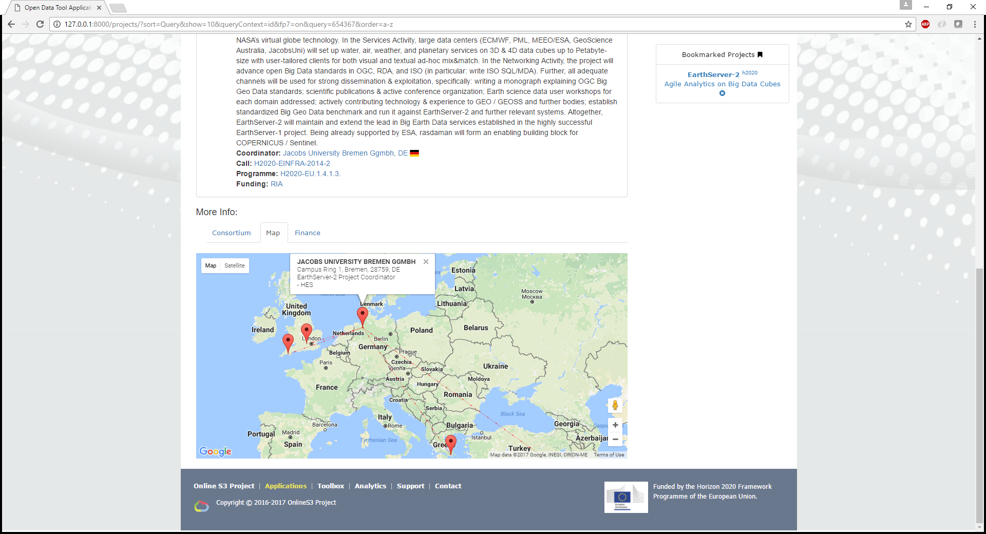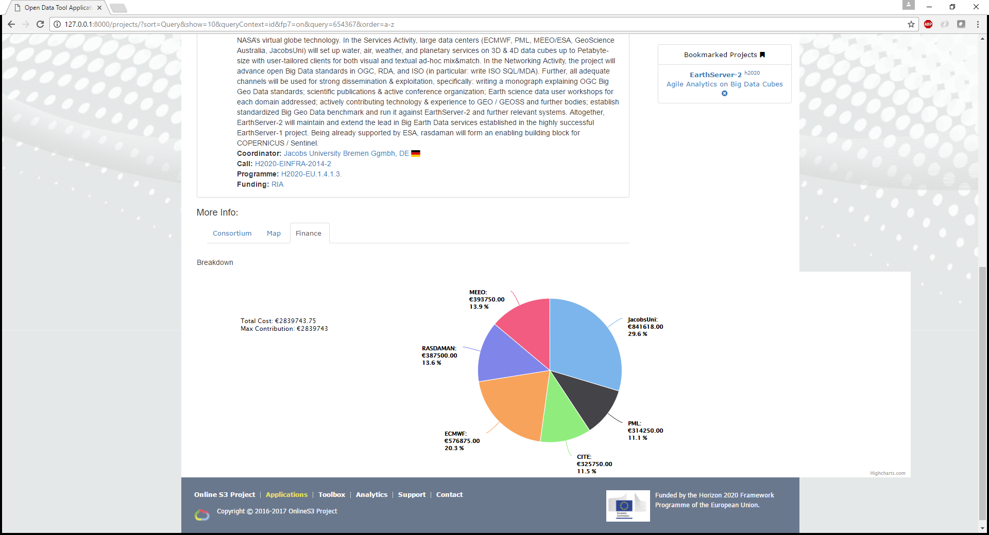

Figure 6 Step 2 for using this ONLINE S3 application

1. Save projects to the bookmark panel for ease-of-access at a later stage.

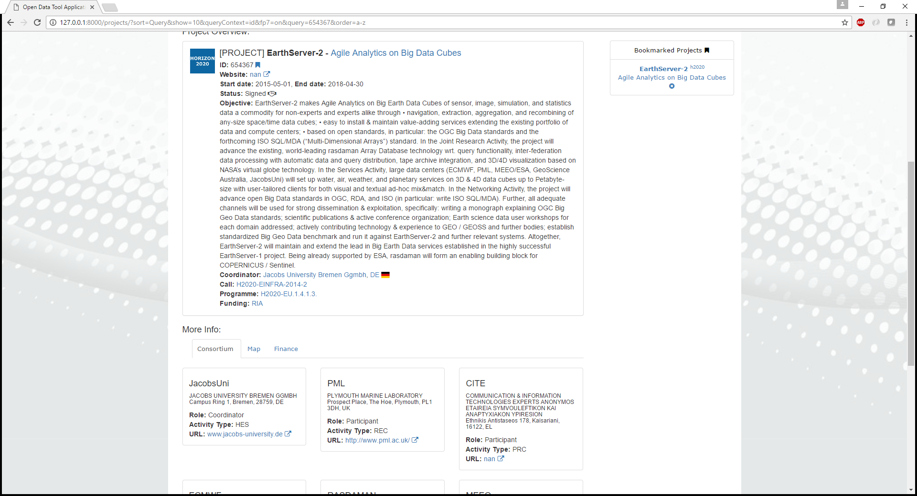

Figure 7 Step 3 for using this ONLINE S3 application

## Further information

Please refer to the RIS Open Data Tool (5.7) methodology fiche created for WP1 of the Online S3 project for further information on the underlying method.

Please refer to the RIS Open Data Tool (5.7) analysis of online applications and e-tools supporting the implementation of the method created for WP2 of the Online S3 project for further information on the design of the tool.

## References

Foray, D., Goddard, J., Goenaga Beldarrain, X., Landabaso, M., McCann, P., Morgan, K., Nauwelaers, C., Ortega-Argilés, R. Guide to Research and Innovation Strategies for Smart Specialisation (Ris 3), Smart Specialisation Platform. Regional Policy. available at <http://s3platform.jrc.ec.europa.eu/s3pguide:> European Commission; 2012.